國 科 會 生 命 科 學 研 究 推 動 中 心
研討(習)會 結案報告
一、基本資料
中文名稱 | 生物化學在生物醫學的新展望
英文名稱 | The Frontiers of Biochemistry in Biomedical Science
中文摘要報告 | 本次研討會是臺灣生化與分子生物學學會每年定期舉辦的學術盛會，今年於2024年11月22日至24日在國立成功大學綠色魔法學校圓滿舉行。會議旨在促進國內生化與分子生物學相關研究人員的交流與合作。今年共有249位與會者報名參加，並邀請了14位傑出講者分享多個研究領域的最新進展與成果。會議包含三場特邀專題演講及多個科學主題時段，涵蓋「後轉譯修飾的動態調控」、「液-液相分離在健康與疾病中的新興角色」及「基因組完整性」等重要議題。本年度特別新增「傑出青年科學家」專題，邀請近期在相關領域取得突破性成果的學者分享研究進展，展現生化與分子生物學領域近年來的快速發展。為促進青年學子參與，會議還設置壁報論文競賽展示，共有148位參與者張貼壁報，並從中選拔8位優秀青年學者進行口頭論文競賽。透過這些報告與展示機會，學生們得以相互交流、啟發研究靈感，並突破研究瓶頸，進一步促進未來合作的可能性。臺灣生化與分子生物學學會透過這項年度學術活動，凝聚國內相關領域的研究人才，促進研究經驗與知識的交流與傳承，協助新一代科研人員的成長，為臺灣生命科學的研究動能與國際能見度持續注入活力。
英文摘要報告 | This conference is an annual academic event organized by the Taiwanese Society for Biochemistry and Molecular Biology (TSBMB). It was successfully held from November 22 to 24, 2024, at the Green Magic School of National Cheng Kung University (NCKU). The conference aims to foster collaboration and communication among researchers in biochemistry and molecular biology across Taiwan. This year, 249 participants attended the event, and 14 distinguished speakers were invited to present the latest advancements and achievements in various research fields. The program included three keynote lectures and several thematic sessions, covering significant topics such as Dynamic Regulation of Posttranslational Modifications, Emerging Roles of Liquid-Liquid Phase Separation in Health and Disease, and Genome Integrity. A notable addition this year was the “Outstanding Young Scientists” session, featuring researchers with groundbreaking achievements in recent years, showcasing the rapid development in biochemistry and molecular biology. To encourage participation from young scholars, the conference also featured a poster display, with 148 participants presenting their work. Eight outstanding young researchers were selected for an oral presentation competition. These opportunities allowed students to engage in knowledge exchanges, inspire research breakthroughs, and pave the way for future collaborations. Through this annual conference, TSBMB brings together the top talents in biochemistry and molecular biology, facilitating the exchange and inheritance of research knowledge and experiences. It also nurtures the growth of the next generation of scientific leaders, contributing to the advancement of life science research in Taiwan and enhancing its international visibility.
研討(習)會目的 | 本次研討會的舉辦，期望能達到以下目的：(1) 提升國內生化分生領域研究能量：本次研討會將邀請國內的專家學者，通過論文發表和專題演講的方式，分享最新的研究成果，促進學術交流與討論。透過這些互動，參與者可以更深入了解生化與分子生物學領域的最新發展趨勢，從而提升研究能力，增強臺灣在此領域的競爭力。(2)促進合作與交流： 本次研討會將匯集來自國內學術界和產業界的頂尖研究者和專業人士，通過三天兩夜的密集交流，增進彼此之間的了解和合作機會。透過分享研究資源和創新技術，建立實質性的合作關係，推動臺灣生化與分子生物學領域的整合與發展。(3) 培育未來人才： 研討會不僅邀請國內知名的專家學者參與，還吸引了大量年輕學生參加論文發表和專題演講。透過展示研究成果和與專家的互動，學生們可以拓展視野，深入理解生化與分子生物學領域的研究方法和思維，激發他們的研究熱情，培育未來在生化與分子生物科技領域的跨領域人才。
參加對象(含人數) | 1. 主講者14人，主持人7人，工作人員25人。  2. 全台生物化學及分子生物學相關學院之各大系所、學程的師生，合計共約249人。
預期效益達成狀況 | 透過本次研討會的舉辦，預期能夠在多個方面產生積極效益。首先，研討會將提升臺灣在生化與分子生物學領域的研究實力，促使相關研究者在公開會議上展現其研究成果並獲得更多關注。其次，研討會將促進學術界與產業界之間的實質性合作，通過資源共享與技術交流，加速創新成果的轉化與應用。此外，研討會還將為未來生化分子生物科技跨領域人才的培育奠定基礎，提供年輕學者與專家學者互動的機會，激發其研究熱情與創新思維。最終，這些效益將共同推動臺灣在生化分生科技領域的國際競爭力，促進整體研究能量的提升與相關科技創新發展。

二、邀請主講人姓名及學經歷
姓名 | 學歷 | 經歷 | 現任
李芳仁 | 1976 - 1980 B.S. National Taiwan University, Taipei, Taiwan  1982 - 1984 M.S. North Carolina State University, Raleigh, N.C., U.S.A.  1984 - 1986 Ph.D. North Carolina State University, Raleigh, N.C., U.S.A. | 2012-2019: Vice President and Dean, Research and Development, NTU  2009-2012: Director, Branch Office of Research and Development, College of Medicine, NTU  2004-2010: Director, Institute of Molecular Medicine, College of Medicine, NTU  2001-2007: Deputy Director, Department of Medical Research, NTU Hospital  2001-2006: Professor, Institute of Molecular Medicine, College of Medicine, NTU | 2006-present: Distinguished Professor, National Taiwan University
吳昆峯 | 2004 – 2010 博士,  化學系,  美國新澤西州立羅格斯大學  2000 – 2002 碩士,  生命科學研究所,  國立清華大學  1996 – 2000  學士, 生命科學系,  國立清華大學 | 2018-2024: Assistant Research Fellow, Academia Sinica  2022-present: Council member, Taiwan Magnetic Resonance Society  2018-2022: Secretary-General, Taiwan Magnetic Resonance Society  2017-2018: MOST Overseas Recruited Assistant Research Scholar  2012-2017: Postdoc Fellow, St Jude Children’s Research Hospital, Memphis, TN, USA | 2024-present: Associate Research Fellow, Academia Sinica
林愷悌 | National Tsing Hua University B. S. 2002 Life Science  University of California, Riverside  Ph. D.2008  Biomedical Science | 2022~present Associate Professor, National Tsing Hua University  2017-2022 Assistant Professor, National Tsing Hua University  2016-2017 Assistant Research Scholar, National Health Research Institutes | 2022~present Associate Professor, National Tsing Hua University
洪慧芝 | 國防醫學院 R. O. C.生命科學研究所  哲學博士  1995/08至 1999/07  國防醫學院 R. O. C.生物化學研究所  理學碩士  1993/08至1995/07  台北醫學大學 R. O. C.  保健營養系 學士1989/09至1993/06 | 2009-present: Professor, Department of Life Sciences, NCHU  2023-present: Deputy Dean, College of life sciences, NCHU  2022-present: Director, Ph.D. Program in Translational Medicine, NCHU  2022-2023: Director, Rong Hsing Center for Translational Medicine, NCHU  2016-2018: Dean, Office of Research and Development, NCHU  2012-2016: Deputy Dean, Office of Research and Development, NCHU  2008-2014: Director, Institute of Genomics and Bioinformatics, NCHU | 2011-present: Distinguished Professor, Department of Life Sciences, National Chung Hsing University (NCHU)
夏國強 | FuJen Catholic University, Taipei, Taiwan B.S. 1998 Biology  National Yang-Ming University, Taipei, Taiwan M.S. 2000 Biochemistry  The Rockefeller University,  New York, NY, USA Ph.D 2009 Structural Biology and Biochemistry | 2015~2020: Assistant Research Fellow, Institute of Molecular Biology, Academia Sinica, Taipei, Taiwan  2010~2015: Postdoctoral Fellow, The Rockefeller University, Laboratory of Chemistry and Cell Biology  2009~2010: Postdoctoral Fellow, The Rockefeller University, Laboratory of Cell Biology, Howard Hughes Medical Institute | 2020~present Associate Research Fellow, Institute of Molecular Biology, Academia Sinica, Taipei, Taiwan
王琬菁 | 2005 Ph.D. Institute of Molecular Medicine,  National Taiwan University, TaiwanCancer Biology  2000 M.S. Institute of Basic Medical Science,  Chang Gung University, TaiwanCancer Biology  1998 B.S. Zoology,  National Chung-Hsing University, TaiwanZoology | 2014-2020: Assistant Professor, Institute of Biochemistry and Molecule Biology, NYMCU  2013-2014: Memorial Sloan-Kettering Cancer Center Research Associate | 2020- present: Associate Professor, Institute of Biochemistry and Molecule Biology, NYMCU
鄭惠春 | Department of Biochemistry, UT Southwestern Medical Center, USA PH.D 2011 Molecular  Biophysics  Institute of Bioinformatics and Structural Biology, National Tsing Hua University M.S. 2004 Structural Biology  Department of Life Science, National Tsing Hua University B.S 2002 Life Science | 2022-2014: Assistant Professor, Institute of Bioinformatics and Structural Biology, NTHU | 2022-present: Associate Professor, Institute of Bioinformatics
楊長賢 | 國立台灣師範大學 生物系學士 1981/7  美國加州大學戴維斯分校 (UC Davis) 遺傳學 博士 1992/7 | 2015~2023: Vice President for Academic Affairs, National Chung Hsing University  2007~2015: Distinguished Professor, Institute of Biotechnology, NCHU  2005~2011: Director, Biotechnology Center, NCHU | 2015~present: Chair Professor, Institute of Biotechnology, National Chung Hsing University
王書品 | National Defense Medical Center Taipei, Taiwan  PhD., Tri-Institutional Program of Life Sciences 2002-2009  Advisor: Dr. Pan-Chyr Yang  National Tsing-Hua University Hsinchu, Taiwan  M.S., Institute of Life Sciences 1999-2002  Advisors: Drs. Cheng-The Wang and Ru-Hua Lin  National Sun Yat-Sen University Kaohsiung, Taiwan  B.S., Department of Biological Sciences 1995-1999  Advisor: Dr. Jiin-Tsuey Cheng | 2015-2018:Research Associate The Rockefeller University New York, USA Laboratory of Biochemistry and Molecular Biology Advisor: Dr. Robert G. Roeder  2010-2015:Postdoctoral Researcher The Rockefeller University New York, USA Laboratory of Biochemistry and Molecular Biology Advisor: Dr. Robert G. Roeder | 2018-present:Assistant Research Fellow Institute of Biomedical Sciences (IBMS), Academia Sinica (AS)Laboratory of Epigenetics and Chromatin Biology
李政昇 | 2009.09-2015.09  2002.09-2006.06  Ph.D. Department of Biology, Brandeis University, Waltham, MA, USA  Thesis Advisor: James E. Haber  B.S. Department of Life Science, National Tsing Hua University, Hsinchu, Taiwan | 2019- present: Assistant Professor, Institute of Molecular and Cellular Biology, NTHU | 2019- present: Assistant Professor, Institute of Molecular and Cellular Biology, NTHU
張雋曦 | 2002-2007 Ph.D. (Molecular Medicine)  Faculty of Medical and Health Sciences,  The University of Auckland, New Zealand  1998-2001 B.Tech(Hons) (Biomedical Science, 1st Class Honor)  Interfaculty Program,  The University of Auckland, New Zealand | 2021- Present: Professor  Department of Pharmacology and Institute of Basic Medical Sciences, College of Medicine, NCKU  2020-2022: Director  Office of International Affairs (Division of College of Medicine)College of Medicine, NCKU  2016-2021: Associate Professor  Department of Pharmacology and Institute of Basic Medical Sciences, College of Medicine, NCKU | 2022- Present : Director  Division of Overseas Students and Scholars Services & Global Competence Advancement Center Office of International Affairs (OIA), National Cheng Kung University (NCKU)
謝世良 | National Yang Ming Chiao Tung University Taipei, Taiwan  Biochemistry, University of Oxford, UK  Stanford University (mentor: Hugh McDevitt) | 2013-2014: Distinguished Professor, Academia Sinica, Taiwan  2000-2013: Professor and Director, Institute of Microbiology and Immunology (2003- 2005) and Institute of Clinical Medicine (2010-2013) | 2013-now: Director, Immunology Research Center, NHRI, Taiwan  2013-now: Adjunct Professor, NYCU
陳昇宏 | Harvard Med. Sch PDF 2016 Systems Biology  Univ. California, San Diego, USA Ph. D. 2008 Biological Sciences  Univ. Sussex, UK M.S 2001 Sch. of Informatics  NTU Bachelor 1998 Dept. Zoology | 2011-2016: Postdoctoral Research Fellow, Department of Systems Biology, Harvard Medical School  2010-2011: Postdoctoral Research Fellow, University of California, San Francisco | 2016-present: Assistant Research Fellow, Institute of Molecular Biology, Academia Sinica  2018-present: Adjunct Assistant Professor, Department of Life Science, National Taiwan University
陳曄 | 1994/09- 1998/06 B.S. Department of Nutrition, China Medical University, Taiwan  1998/09- 2000/06 M.S. Institute of Biochemistry, National Defense University, Taipei, Taiwan  2000/09- 2005/06 Ph.D. Institute of Biochemistry, National Chung Hsing University, Taichung, Taiwan | 2020-2022: Associate Professor, Institute of New Drug Development, China Medical University, Taiwan  2015-2020: Associate Professor, Department of Biotechnology, Hungkuang University, Taiwan  2009-2015: Assistant professor, Department of Biotechnology, Hungkuang University, Taiwan | 2022-present: Associate Professor, Department of Food Science and Biotechnology, National Chung Hsing University, Taiwan

三、議程
日期 | 議程時間 | 議程講員 | 議題主題
2024-11-22 | 13:10:00-14:10:00 | 李芳仁  教授級/研究員 | Keynote-1
2024-11-22 | 14:30:00-16:00:00 | 洪慧芝  教授級/研究員 | Session-1 Dynamic regulation of posttranslational  modification
2024-11-22 | 14:30:00-16:00:00 | 吳昆峰 副研究員 | Session-1 Dynamic regulation of posttranslational  modification
2024-11-22 | 14:30:00-16:00:00 | 林愷悌 副教授 | Session-1 Dynamic regulation of posttranslational  modification
2024-11-22 | 16:30:00-18:00:00 | 夏國強 副研究員 | Session-2 Emerging roles of liquid-liquid phase  separation in health and disease
2024-11-22 | 16:30:00-18:00:00 | 王琬菁 副教授 | Session-2 Emerging roles of liquid-liquid phase  separation in health and disease
2024-11-22 | 16:30:00-18:00:00 | 鄭惠春 副教授 | Session-2 Emerging roles of liquid-liquid phase  separation in health and disease
2024-11-23 | 09:00:00-10:00:00 | 楊長賢 院士 | Keynote-2
2024-11-23 | 10:30:00-12:00:00 | 王書品 副研究員 | Session-3 Genome Integrity
2024-11-23 | 10:30:00-12:00:00 | 李政昇 助理教授 | Session-3 Genome Integrity
2024-11-23 | 10:30:00-12:00:00 | 張雋曦 教授 | Session-3 Genome Integrity
2024-11-24 | 09:00:00-10:00:00 | 謝世良 特聘研究員 | Keynote-3
2024-11-24 | 10:30:00-12:00:00 | 陳昇宏 助理研究員 | Session-4 Outstanding Young Scientists
2024-11-24 | 10:30:00-12:00:00 | 陳曄 副教授 | Session-4 Outstanding Young Scientists

四、活動照片和影片

- 照片(至少10張，請填寫照片說明)

大合照
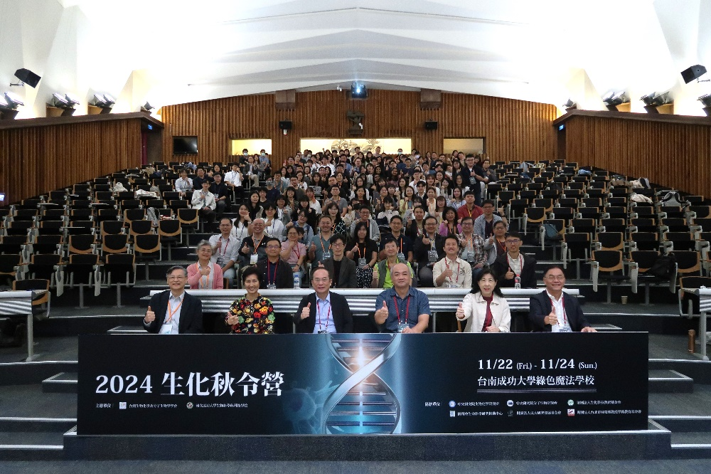
場地
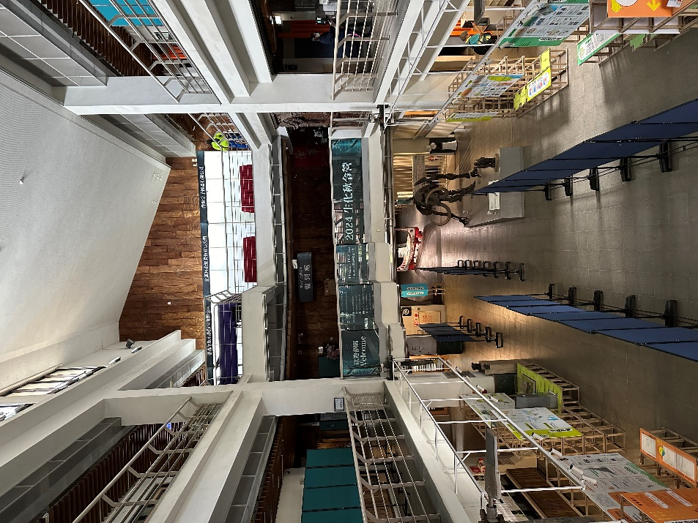

海報競賽
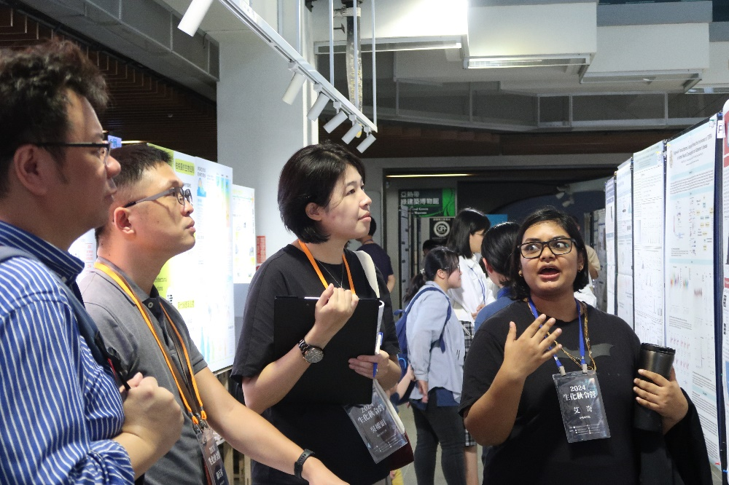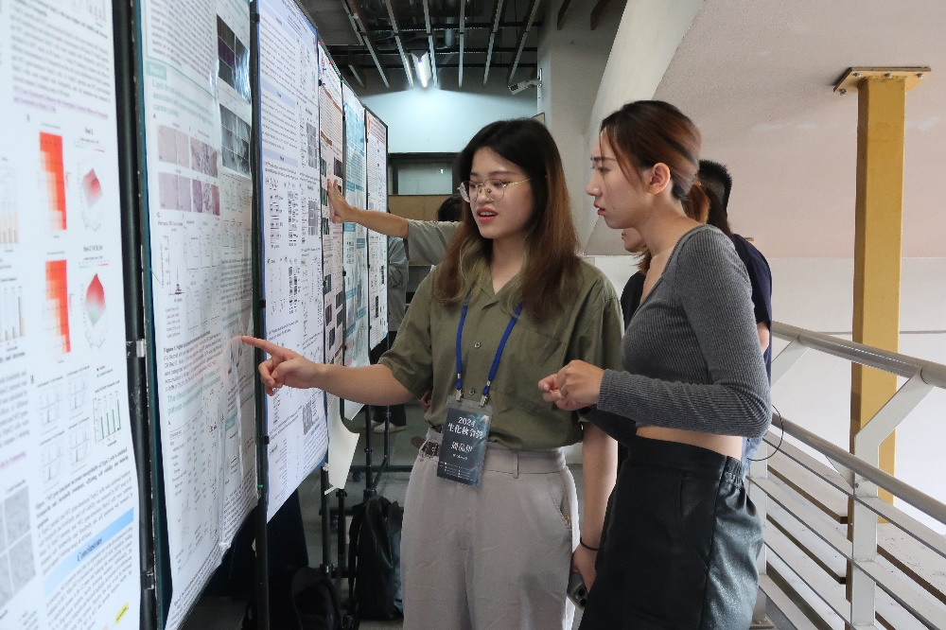
口頭競賽
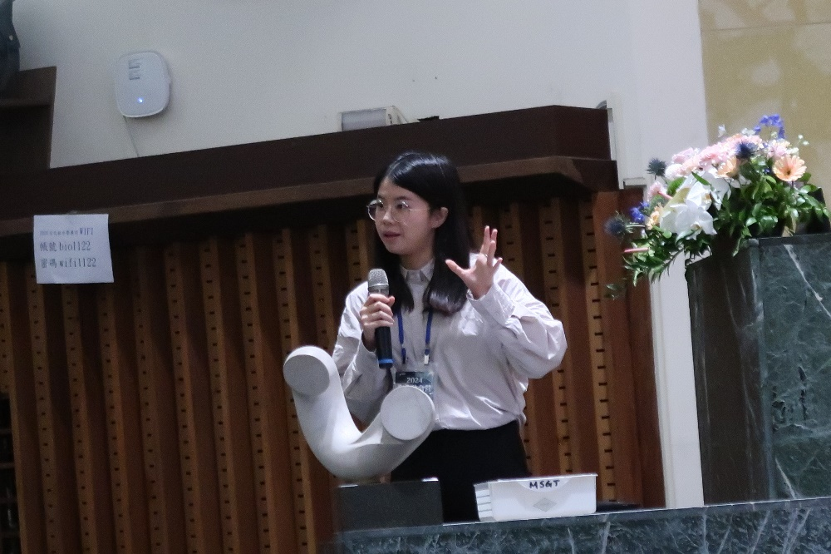

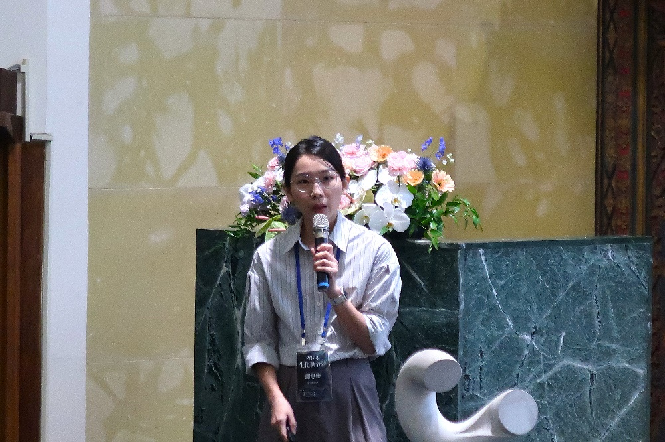
講者—keynote1 CHAIR王憶卿老師
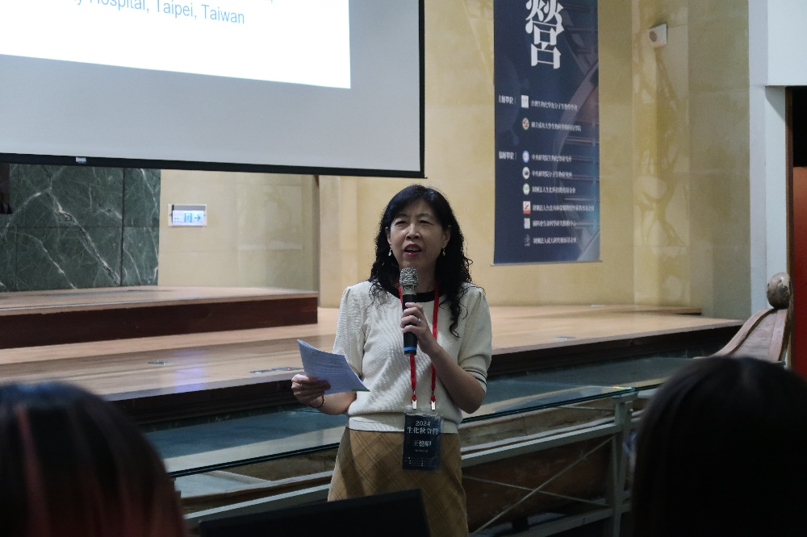
講者—keynote1李芳仁老師
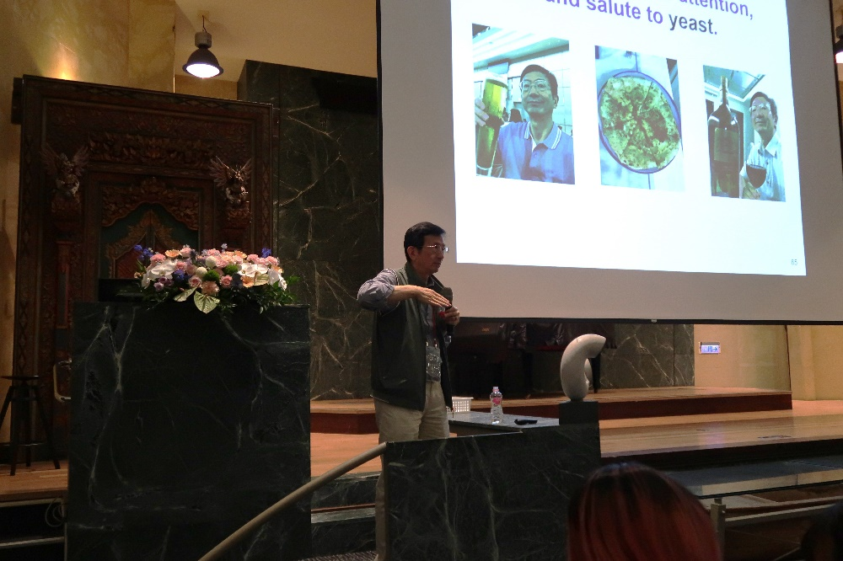

講者—keynote3謝世良
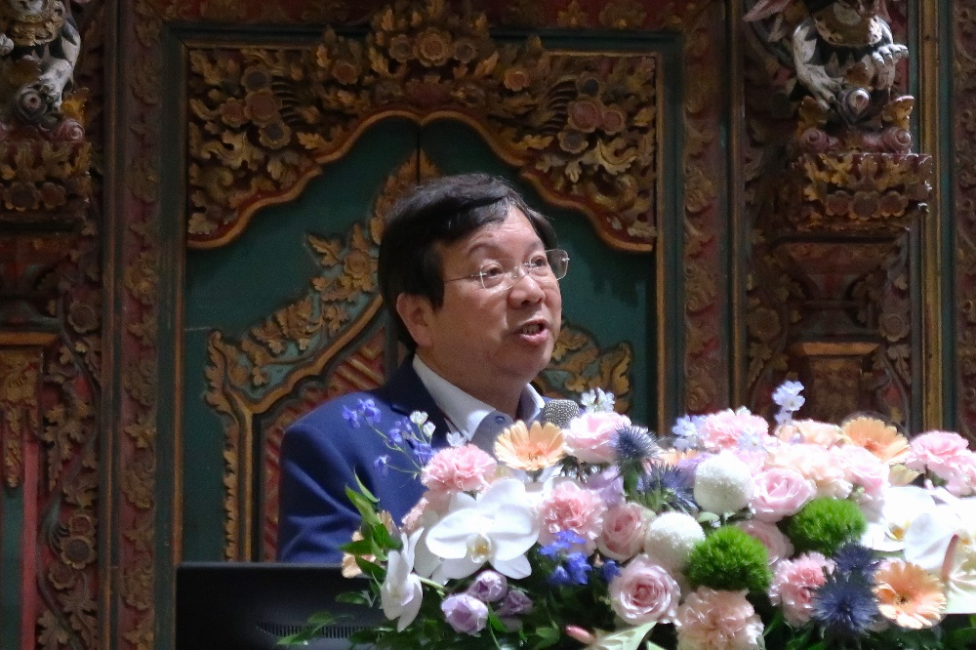
講者—session4陳曄

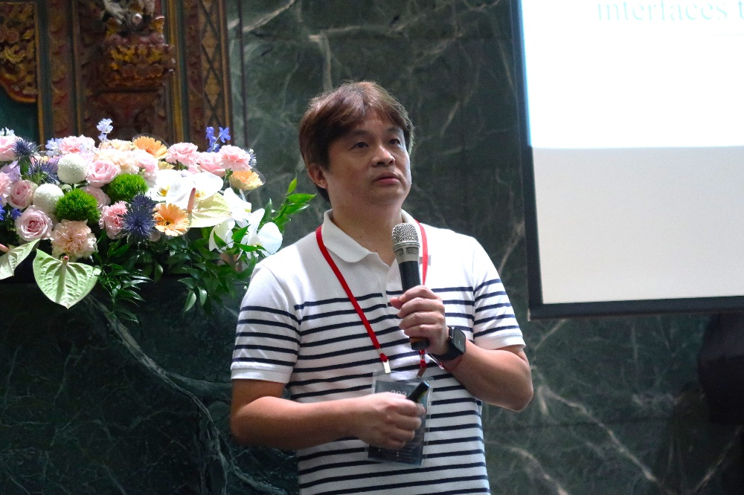

閉幕頒獎
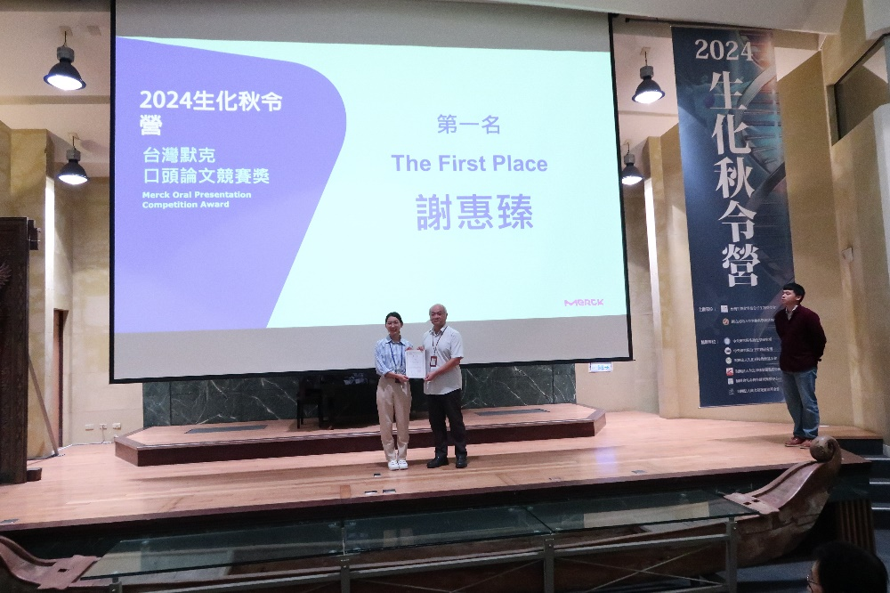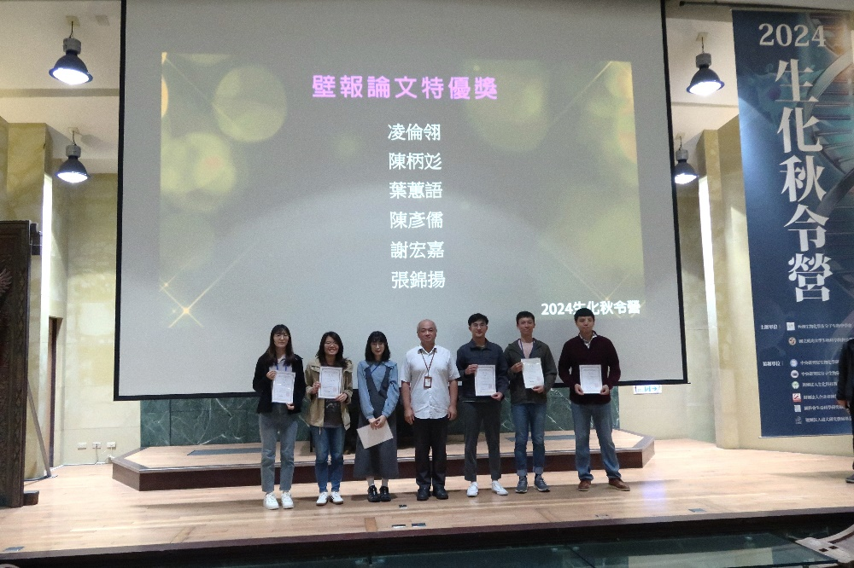

- 影片(1-2分鐘精華短片，請上傳至結案報告專區，並提供檔案名稱)

