國 科 會 生 命 科 學 研 究 推 動 中 心
研討(習)會 結案報告
一、基本資料
中文名稱 | 國際醫學合作交流計畫- 2024 跨國學術交流會
英文名稱 | International Collaboration and Exchange Program (ICEP) - 2024 Academic Immersion Travel in Taiwan
中文摘要報告 | 此次國際醫學合作交流計畫為期五天，旨在促進全球醫學專業人員之間的學術交流與合作。來自多國的醫學專家、學者及學生參與了本次活動，涵蓋了國際講座、圓桌討論、小組合作以及文化參訪等多元環節。主要討論的議題包括全球公共衛生領導、疫情防控、醫學倫理、肺癌的精準預防與治療，以及AI技術在醫療中的應用。透過這些深入的學術討論，參與者增強了專業知識，並獲得了寶貴的跨國合作經驗。  此外，參訪活動如台大微創手術中心、醫學人文館、解剖博物館以及中研院國家生技園區，讓國際參與者對台灣的醫療實力與文化有了更深的認識。參與者對台灣的先進醫療技術及其文化背景留下了深刻的印象。  本次計畫不僅促進了學術合作，也強化了台灣在國際醫學界的影響力。通過建立國際醫學網絡，未來的研究和合作有望更加緊密，為全球醫學發展和公共衛生挑戰提供了新的契機。台灣的醫療與學術實力在此次活動中得到了充分展示，為促進長期的國際學術合作奠定了基礎。
英文摘要報告 | The five-day International Collaboration and Exchange Program aimed to promote academic exchange and cooperation among medical professionals from around the world. Medical experts, scholars, and students from various countries participated in the event, which included international lectures, roundtable discussions, group collaborations, and cultural visits. The main topics covered were global public health leadership, pandemic prevention, medical ethics, precision prevention and treatment of lung cancer, and the application of AI in healthcare. Through these in-depth academic discussions, participants enhanced their professional knowledge and gained valuable experience in international collaboration.  Additionally, site visits to the NTU Minimally Invasive Surgery Center, the Humanities Museum, the Anatomy Museum, and the National Biotechnology Research Park provided international participants with a deeper understanding of Taiwan’s medical strengths and cultural background. Many participants were impressed by Taiwan's advanced medical technology and rich cultural heritage.  This program not only strengthened academic cooperation but also increased Taiwan’s influence in the global medical community. By building an international medical network, future research and collaborations are expected to be more connected, offering new opportunities for tackling global medical challenges and improving public health. Taiwan’s medical and academic strengths were fully demonstrated, laying a solid foundation for long-term international academic cooperation.
研討(習)會目的 | - 提升醫學教育和專業發展：透過國際講座、跨國合作和研究交換，增強醫學生與年輕醫師的專業知識與技能，培養未來的國際醫學領導者。  - 促進國際學術交流與合作：提供平台讓全球醫學生和專家分享知識與經驗，促進台灣醫學界與國際同行的合作。  - 展示台灣醫療實力和文化：透過實地參訪與文化交流活動，展示台灣的醫療實力及文化魅力。  - 強化國際人脈與合作：透過互動和合作，建立長期的國際人脈，推動未來醫學研究和公共衛生合作。  - 推動醫學政策與公共衛生發展：涵蓋公共衛生、疫情防控、精準醫療等主題，啟發醫學生思考並討論醫學政策及其實際應用。
參加對象(含人數) | 共93人參與  台灣(學員+工作人員) 54人  德國、英國、美國、日本、新加坡等國 39人
預期效益達成狀況 | - 提升醫學教育和專業發展：  參與者通過國際講座和跨國小組合作，增強了專業知識和技能。國際專家分享了最新的研究進展，幫助台灣醫學生和年輕醫師拓展了全球醫學視野，並強化了他們在醫學領域的領導能力。  - 促進國際學術交流與合作：  通過此次會議，來自不同國家的專家和學生分享了他們的研究成果與經驗，尤其是在跨國討論環節如 Student Interactive Discussion 和 Roundtable Discussion，參與者在討論全球公共衛生議題中積極互動，促進了台灣與國際醫學界的合作與交流。  - 展示台灣醫療實力和文化：  參訪活動包括台大微創手術中心、台大醫學人文館、解剖博物館等醫學設施，展示了台灣在醫學教育及技術上的卓越成就。參與者還參觀了中研院國家生技園區，了解台灣在生物技術和醫學創新領域的領先地位。這些參訪活動增強了外國學者對台灣醫療實力的認識，同時也提升了台灣的國際形象。  - 強化國際人脈與合作：  藉由 Student Interactive Discussion 和 Roundtable Discussion，參與者能夠面對面地討論全球醫學議題，並與來自世界各地的醫學生和專家建立了長期的聯繫，為未來的國際合作打下基礎。  - 推動醫學政策與公共衛生發展：  此次會議探討了公共衛生政策、疫情防控等全球議題，為參與者提供了重要的學術參考。錢宗良教授、Anette Wu博士及W. Ian Lipkin博士一同拜訪了衛福部，與陳建仁院士會面，進行了關於公共衛生發展的深入交流，這對台灣在國際醫學領域的政策推動起到了積極作用。

二、邀請主講人姓名及學經歷
姓名 | 學歷 | 經歷 | 現任
Sir Rory Collins | PhD in Epidemiology, University of Oxford | - Since 1985, he has co-directed the Clinical Trial Service and Epidemiological Studies Unit  - Founder of UK Biobank, Expert in Meta-analysis | - British Heart Foundation Professor of Medicine & Epidemiology  - Head, Nuffield Department of Population Health, University of Oxford, UK
Sten H. Vermund, MD, PhD | PhD in Public Health, Yale University | - Dean of the Yale School of Public Health (2017-2022)  - Professor of Pediatrics at Yale School of Medicine. | - Yale School of Public Health  - Yale School of Medicine  - Chair of the Global Virus Network (GVN)
Dr. W. Ian Lipkin, MD | MD, Columbia University | - Director of the Global Alliance for Preventing Pandemics (GAPP), Mailman School of Public Health & Vagelos College of Physicians and Surgeons, Columbia University Irving Medical Center.  - Member of the WHO Global Outbreak Response Network. | - Director of the Center for Infection and Immunity  - John Snow Professor of Epidemiology  - Professor of Neurology and Pathology & Cell Biology.
Dr. Pan-Chyr Yang 楊泮池 | MD, National Taiwan University | President of NTU, 2013-2017 | - Academician of Academia Sinica  - Professor of Internal Medicine at National Taiwan University College of Medicine  - Vice President of the National Biotechnology and Medical Care Promotion Association.
Sabine Hildebrandt MD | PhD in Anatomy, Heidelberg University | - co-editor of the book "Recognizing the Past in the Present: Medicine before, during and after the Holocaust  - co-chair of the Lancet Commission on Medicine and the Holocaust: Historical Evidence, Implications for Today, Teaching for Tomorrow | - Lecturer on Global Health and Social Medicine at Harvard Medical School  - Associate Professor of Pediatrics at Boston Children’s Hospital.
Dr. Fu-Chang Tsai | MD, National Taiwan University | - Founding professor of the Graduate Institute of Medical Education & Bioethics, NTU  - Director of the Center for Biomedical Ethics, NTU, and the Department of Social Medicine, NTUCM  - Chairman of the Research Ethics Committee and executive secretary of the Clinical Ethics Committee at NTU Hospital  - Awarded Honorary Membership by UNESCO Chair of Bioethics (2015), Goldman-Berland Lectureship in Palliative Medicine (2019), and Hastings Center Fellow (2021) | Associate Professor in the Department of Social Medicine and Family Medicine at National Taiwan University College of Medicine  Attending Physician in the Department of Medical Research at National Taiwan University Hospital.  Joint professor in the Department of Family Medicine and Graduate Institute of Clinical Medicine, NTUCM

三、議程
日期 | 議程時間 | 議程講員 | 議題主題
8月31日 | 16:00 - 17:00 | Sir Rory Collins | Post-Truth Medicine: Death and Disability by Disinformation
 | 9:00 - 10:30 | Sten H. Vermund, MD, PhD | Leadership for a Public Health System in Crisis
  9月1日
9月2日 | 9:00 - 10:30 | Dr. W. Ian Lipkin, MD | Global Alliance for Prevention on Pandemics
9月2日 | 10:40 - 12:00 | Dr. Pan-Chyr Yang 楊泮池 | Lung adenocarcinoma in East asian women: mechanism and early screening
9月3日 | 9:00 - 10:30 | Sabine Hildebrandt MD | Ethics in Anatomy –  The Meaning of Anatomy Education Today
9月3日 | 10:40 - 12:00 | Dr. Fu-Chang Tsai  蔡甫昌 | Ethics at the Forefront of AI Technology

四、活動照片和影片
- 照片(至少10張，請填寫照片說明)

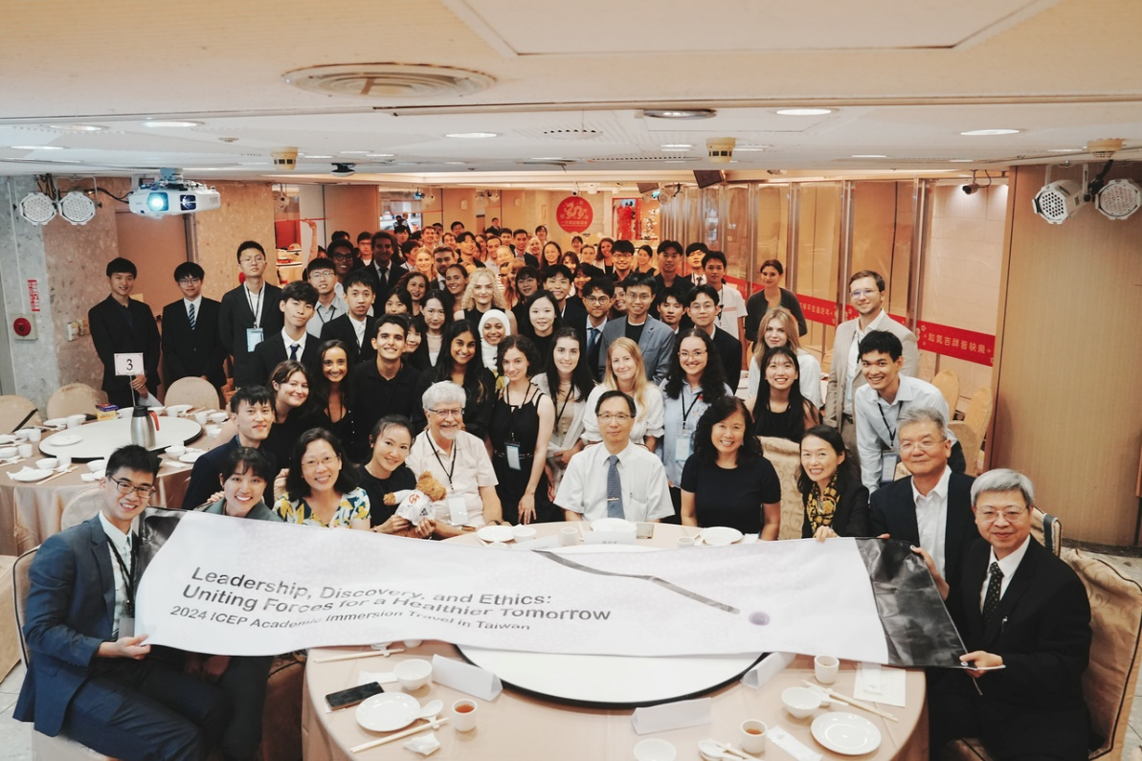
開幕式團體照。左一活動總召王昱翔同學；右一台大醫學系盛望徽主任；右二本計畫主持人錢宗良教授；右三ICEP主持人Dr. Anette Wu。
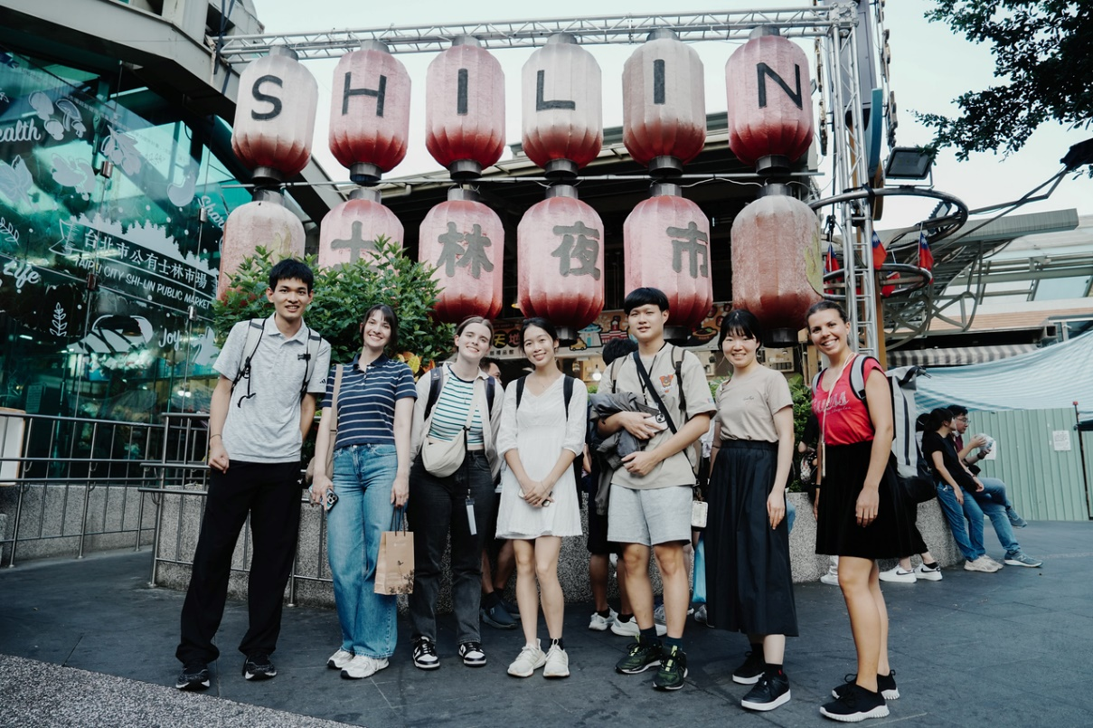
士林夜市參訪活動
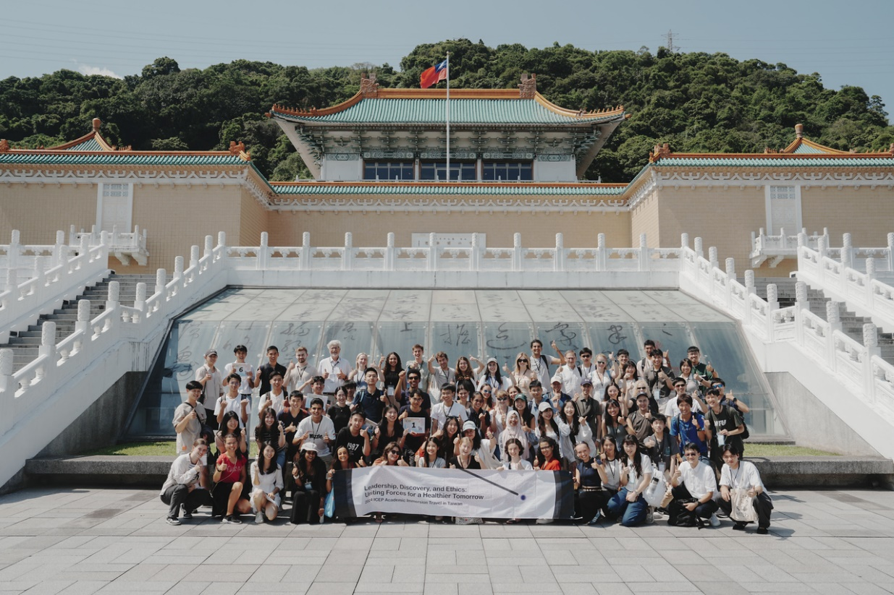
故宮博物院巡禮
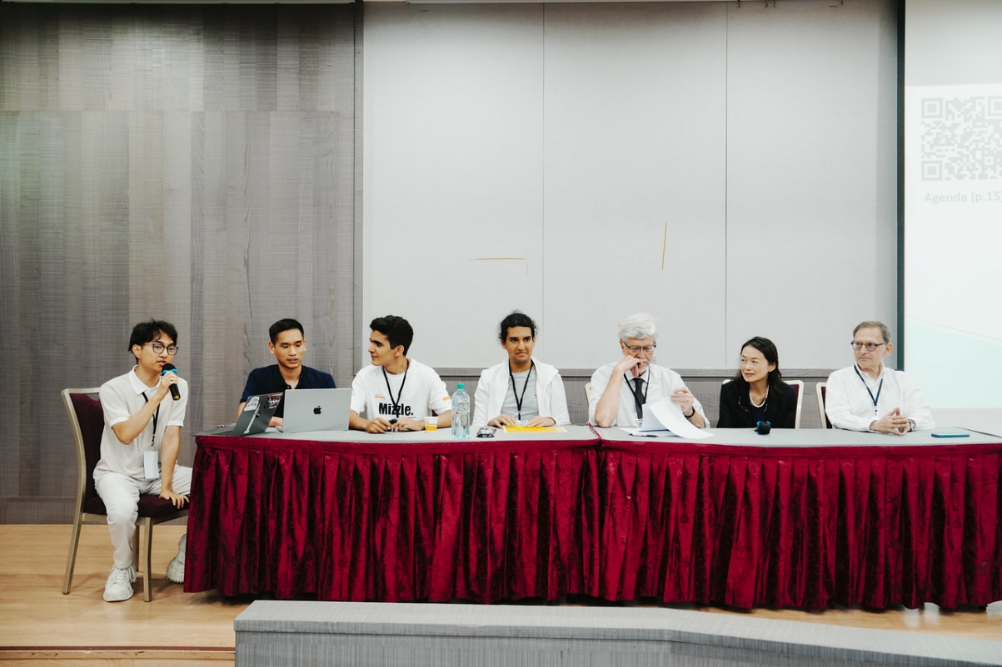
Student interactive discussion。右一: Dr. Sten H. Vermund 右二: Dr. Anette Wu 右三: Ian W. Lipkin
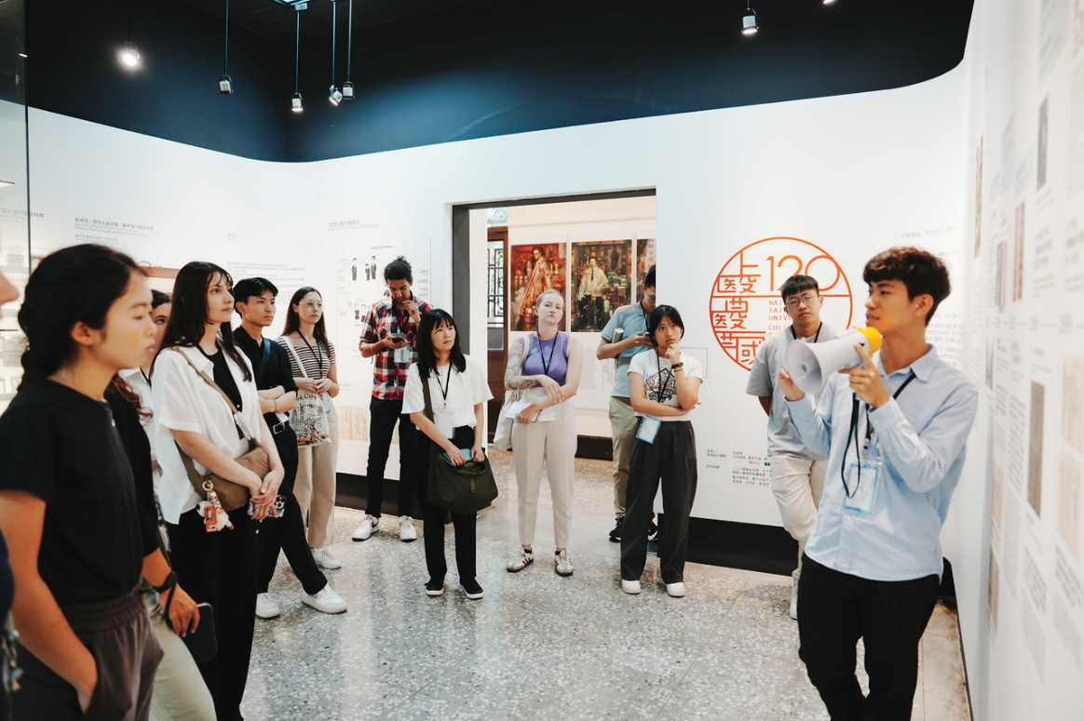
台大醫學人文博物館參訪，由人文博物館學生導覽員講解台灣醫療史。
臺大醫學院120週年院慶展-上醫醫國
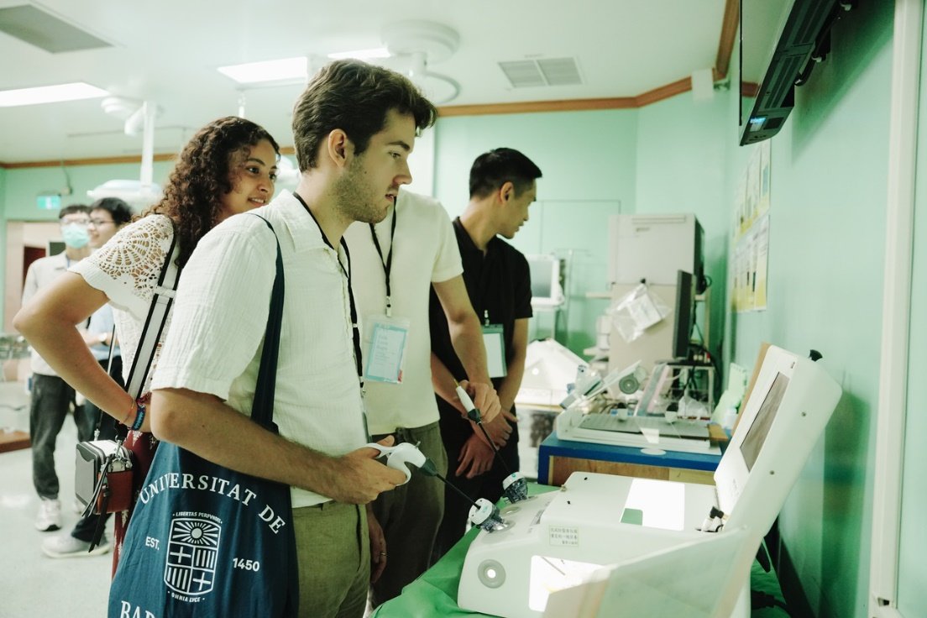
臺大醫院微創手術訓練中心，學生正在嘗試操作內視鏡機械手臂。
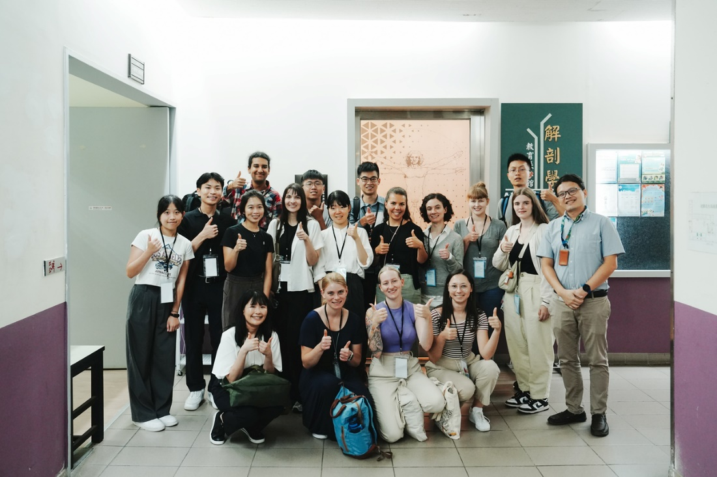
臺大醫學院解剖學博物館參訪。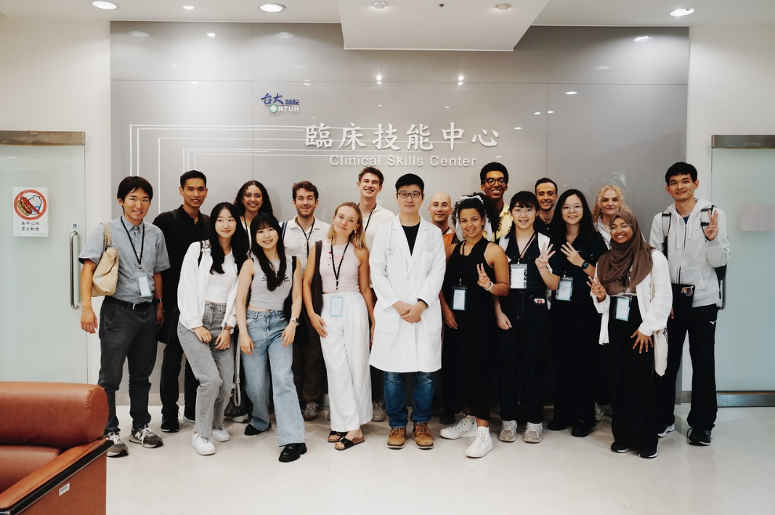
台大醫學院臨床技能中心參訪。
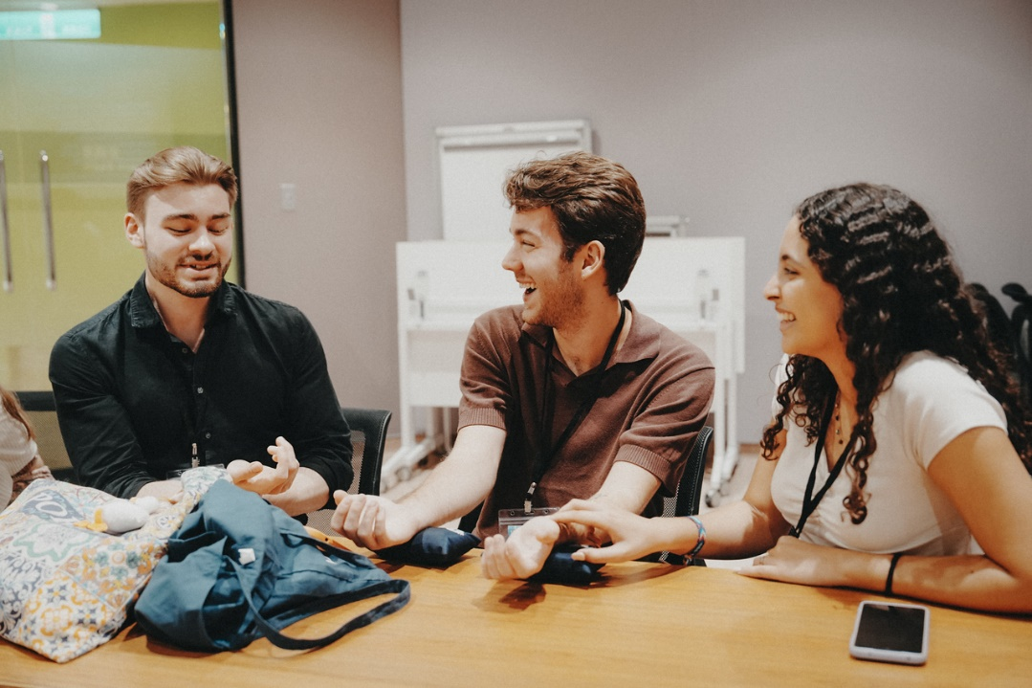
Workshop，中醫工作坊，學生正在學習互相把脈
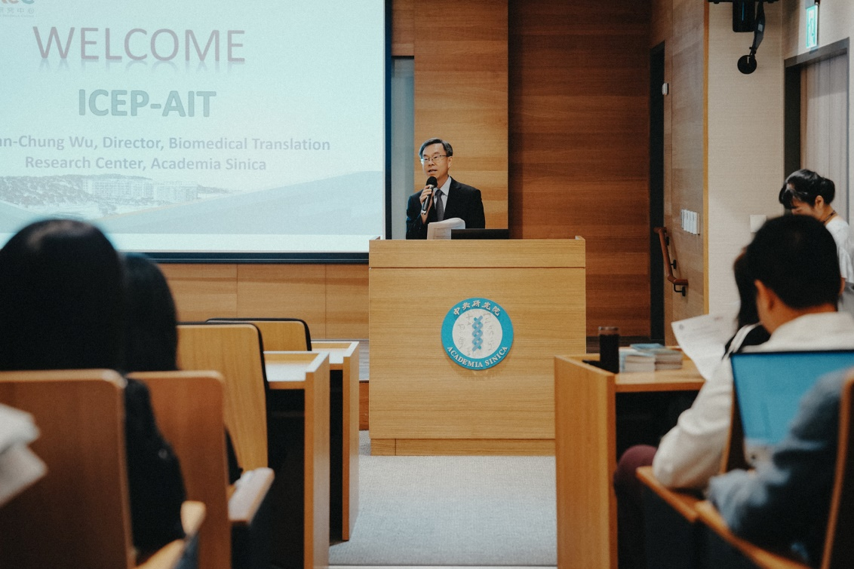
國家生技園區參訪，中研院-生醫轉譯研究中心 吳漢忠主任致詞。
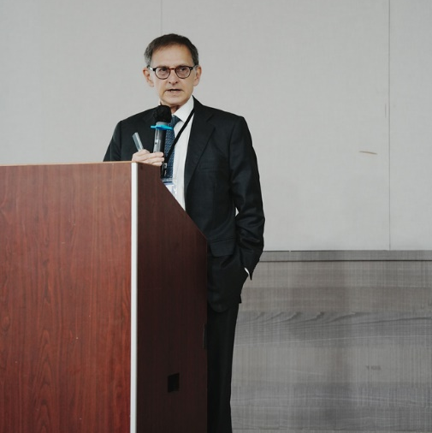
Dr. Ian Lipkin的Keynote speech
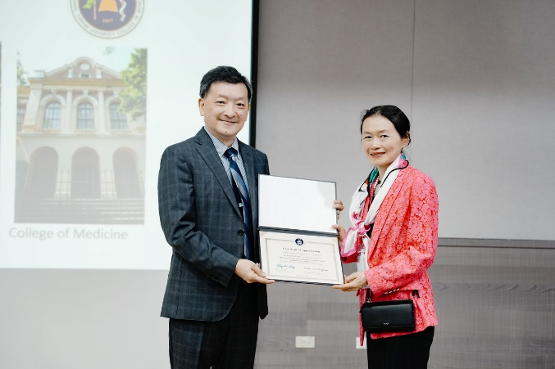
Dr. Fu-Chang Tsai的Keynote speech
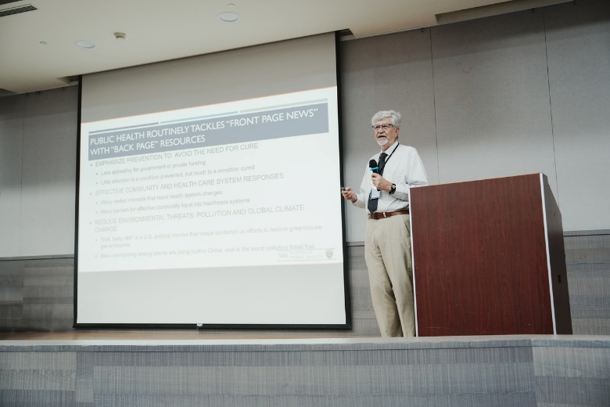
Dr. Sten H. Vermund 的Keynote speech
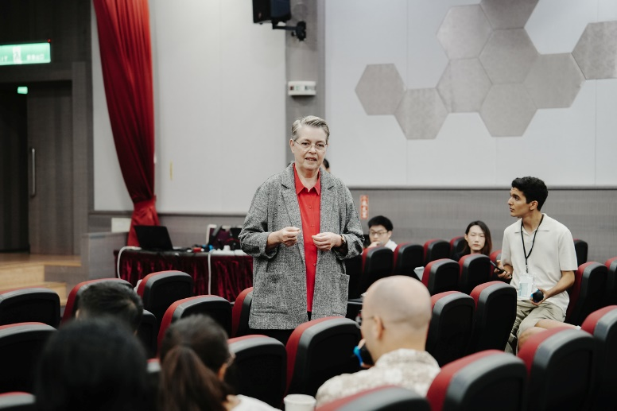
Dr. Sabine Hildebrandt的Keynote speech
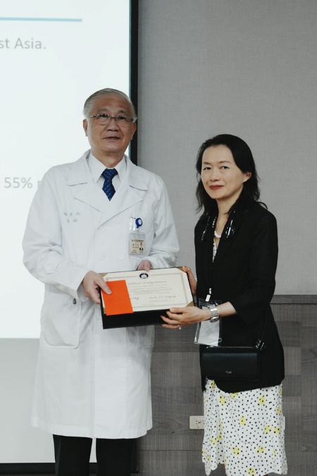
Dr. Pan-Chyr Yang的Keynote speech
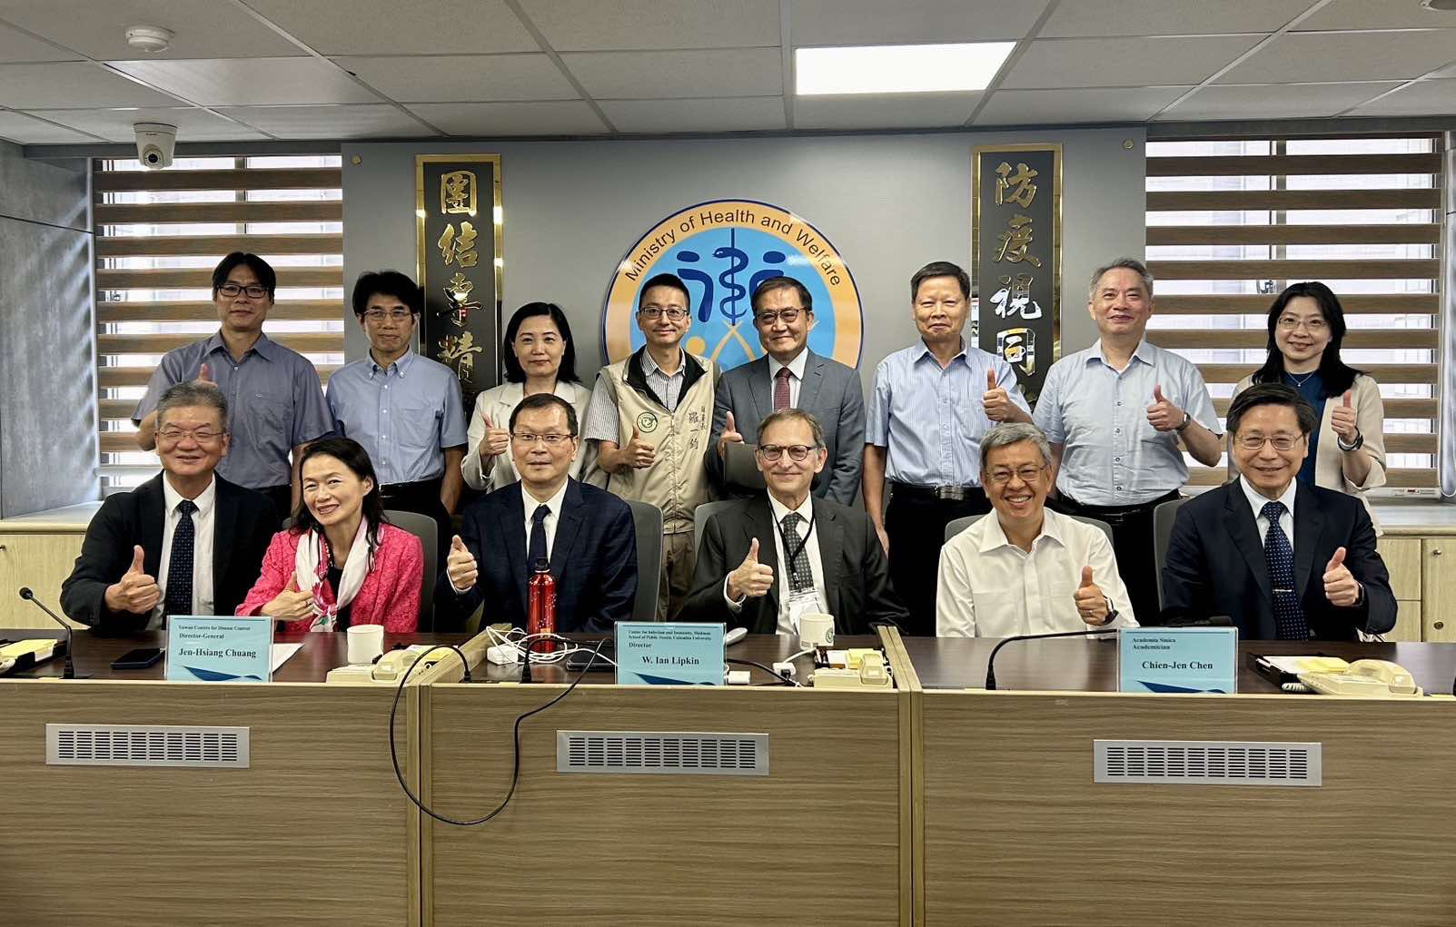
錢宗良教授與Anette Wu博士及W. Ian Lipkin博士一同拜訪衛福部，會見陳建仁院士等。

- 影片(1-2分鐘精華短片，請上傳至結案報告專區，並提供檔案名稱)
https://drive.google.com/file/d/1xuaKFIlc8PogK2XFpwmmne4XIijfZIik/view?usp=sharing

